1. Calculate the area of a circle.

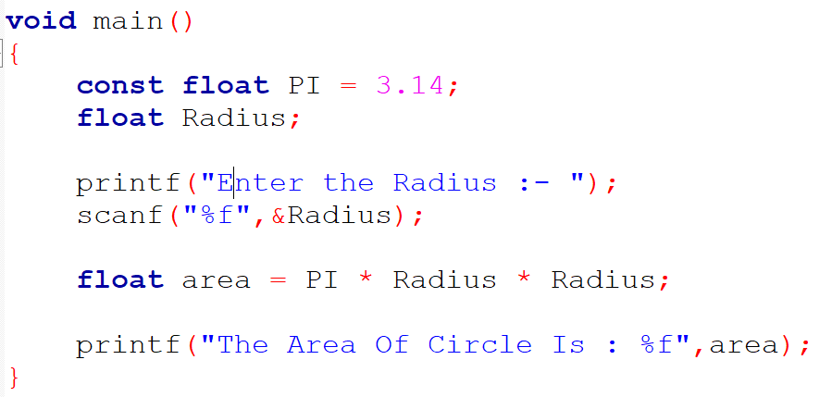

1. Convert temperature from Fahrenheit to Celsius.

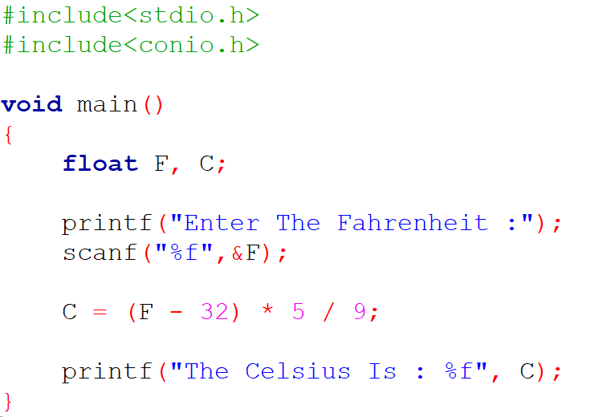

1. Create a program that prints the Fibonacci series.